 Name: Gamal Mohamed Gamal Saad

ID : 1126

Sec : 12

Group : 2 Examiners committee : Dr.Ahmed Bayoumi

Dr.Shady Elmashad

Dr.Abdelhamid Attaby

***Computer engineering role in covid-19 pandemic***

By :

Gamal Mohamed

***1***

***About the Website in the project***

The website consists of a **main** **HTML** file .

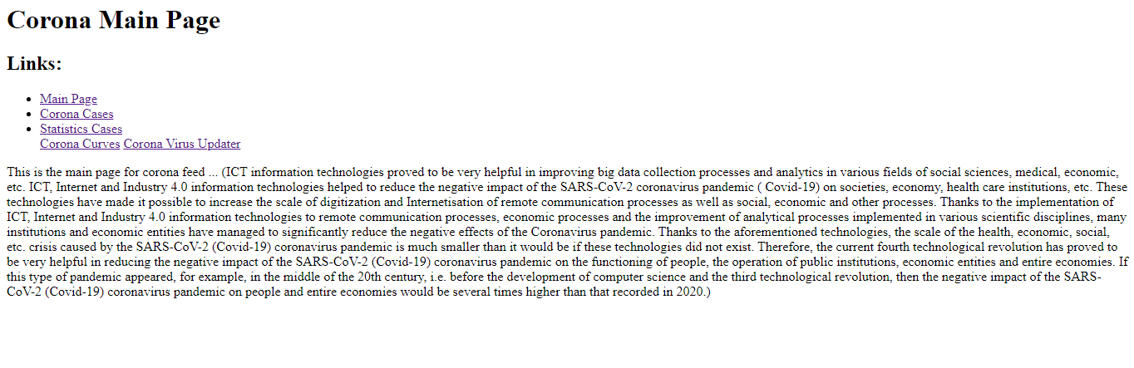

# Source Code :

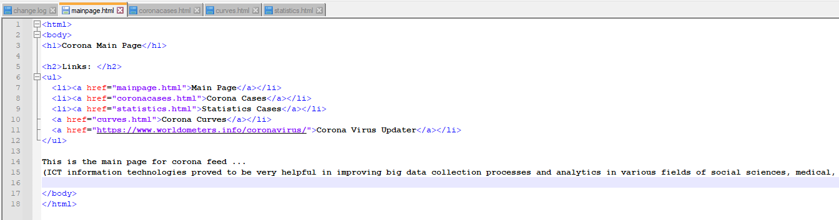

***2***

The website consists of **Corona Cases**

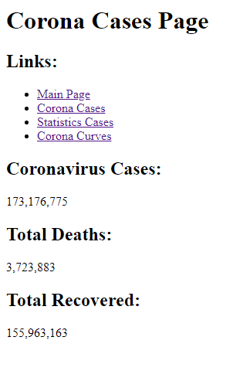

Source Code :

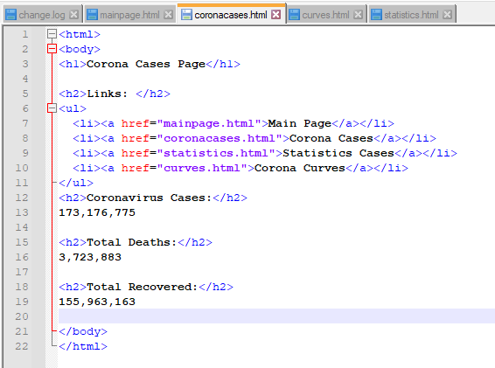

***3***

The website consists of a ***Statistics Cases*** in USA,India and Egypt

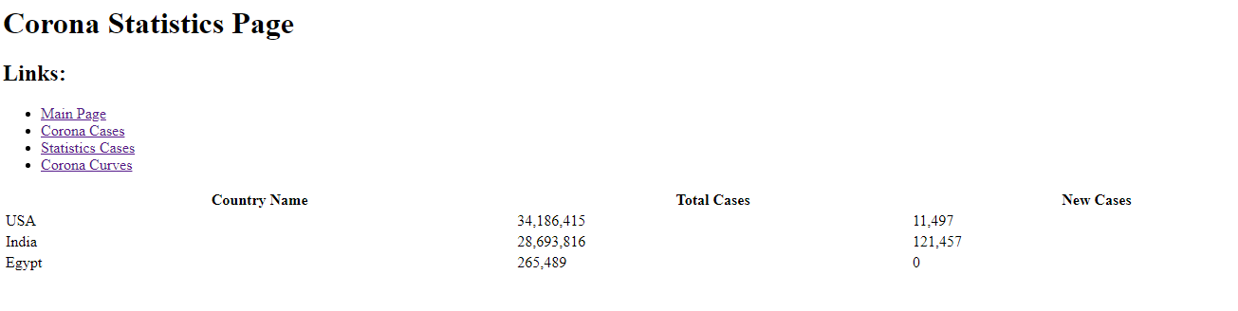

# Source code :

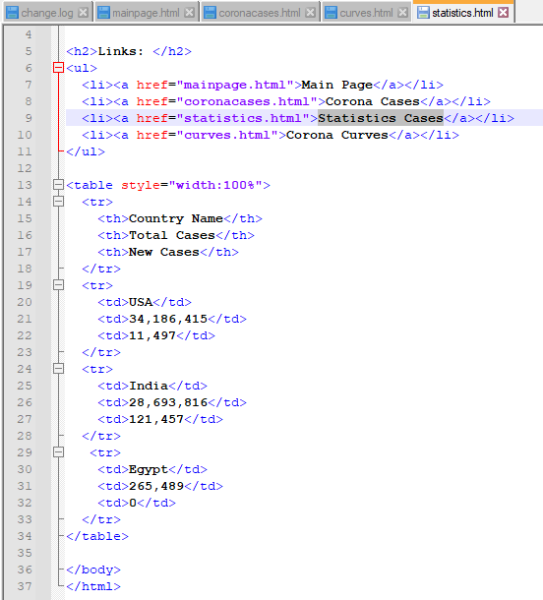

***4***

The website consists of **Corona Curves**  in USA,India and Egypt

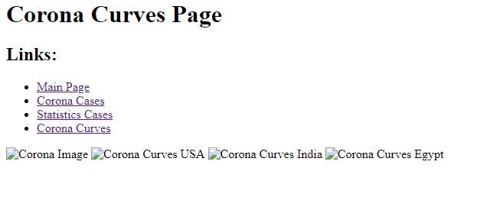

# Source code :

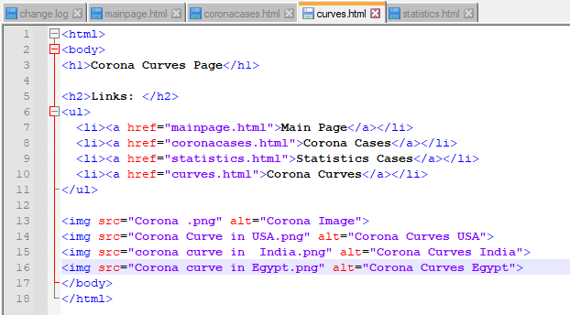

***5***